TOP 10 OF RAM

# 1.COSAIR

Name: CORSAIR Vengeance RGB Pro 32GB

Size : 8GB

Ramtype: DDR4G.Skill:

Pins : 288PIN

Price : : $54.99USD

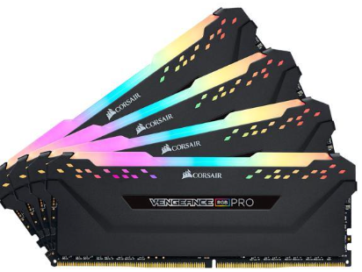

2. G.Skill:

Name: TridentZ Neo

Size : 64GB

Ramtype:DDR4

Pins :288pin

Price : $245

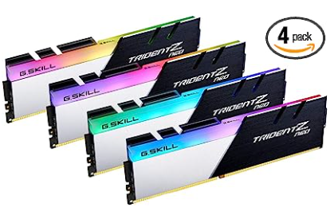

3.Muskin

Name : Silverline

Size : 32GB

Ramtype: DDR4 Desktop

Pins: 288pin

Price: $68

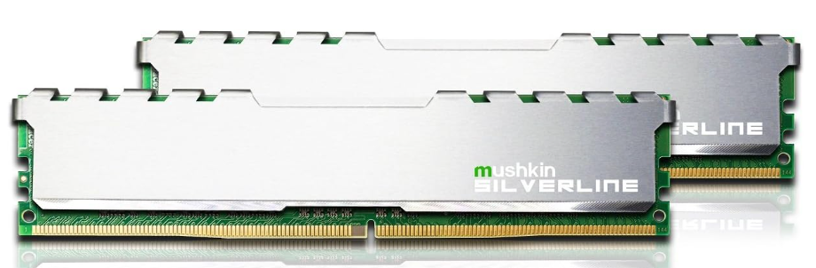

4.Micr

Name: ECC Registered

Size : 32GB

Ramtype: DDR4-2933

Pins :288pins

Price : **$89.85**

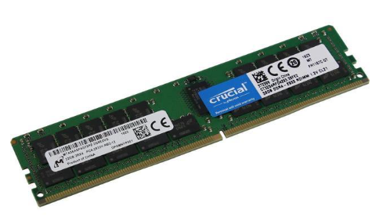

5.Kingston

Name: HyperX fury

Size : 8GB

Ramtype:DDR3

Pins : 240-pins DIMM

Price :

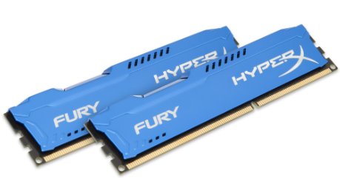

6.xstremeDDR

Name : NCR DDR SDRAM DIMM

Size : 1GB

Ramtype:DDR

Pins : $184 pin

Price : 14.75$

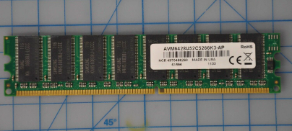

7.OCZ

Name : SDRAM

Size : 4GB

Ramtype: DDR2

Pins : 240-pin

Price : $39.05

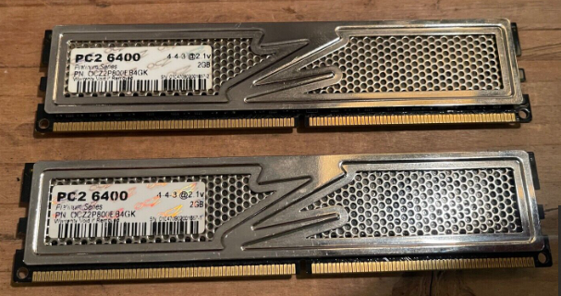

8.Sumsung

Name : Sumsung Original

Size : 16GB

Ramtype: DDR3

Pins :240pins

Price : $54

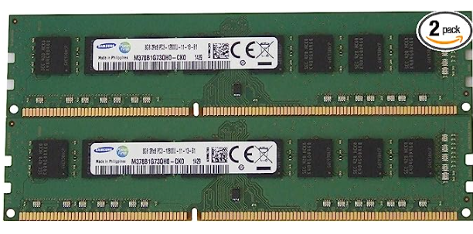

9.Transcand

Name : SATA III SSD

Size : 34GB

Ramtype:2260 MLC

Pins : 32pin

Price : 111.34$

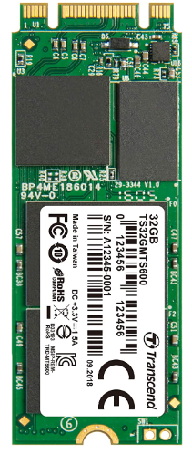

10. Hynic

Name : SK hynix

Size : 256GB

Ramtype: DDR4-3200AA

Pins : 288pins

Price : $663.93

